**Project title: Restaurant Management System**

**Done By:**

**Jaimin Shah**

* **Topics:**

1. **Front End**

* **User side**
* **Admin Side**

1. **Back End**

* **Database**

**Screenshots**

**Front End:**

* **Home Page:**

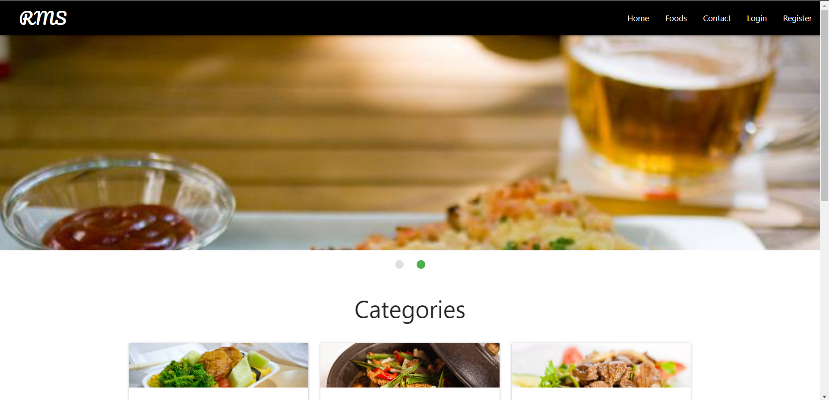

* In this page below we can read the details of the food dish.

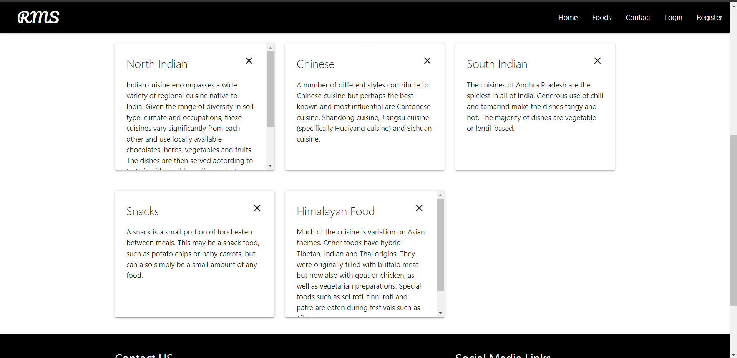

**Register Page:**

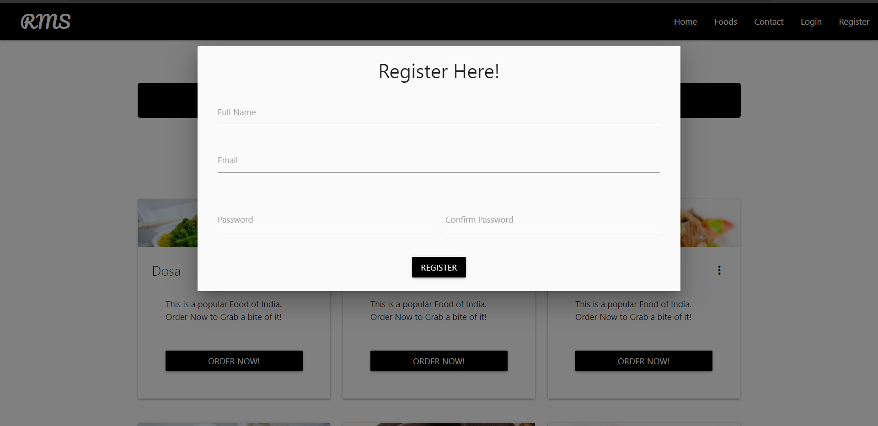

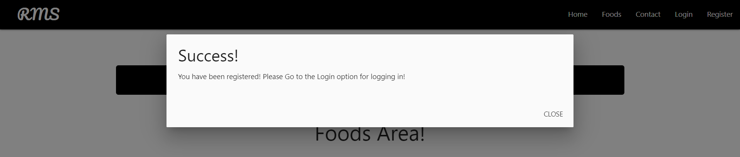

**Login Page:**

* **Food Area Page:**

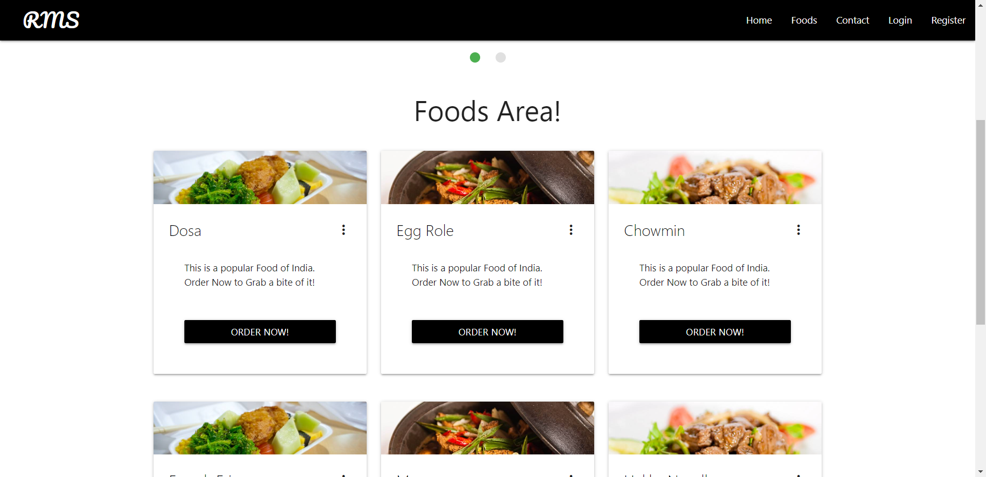

* **We have to first login to order the food.**

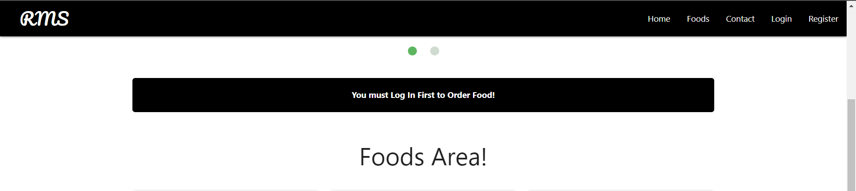

* **After login in we can order our favourite food and the order id will get generated.**

* **Contact Us page:**

**Back-End:**

* **All Tables:**

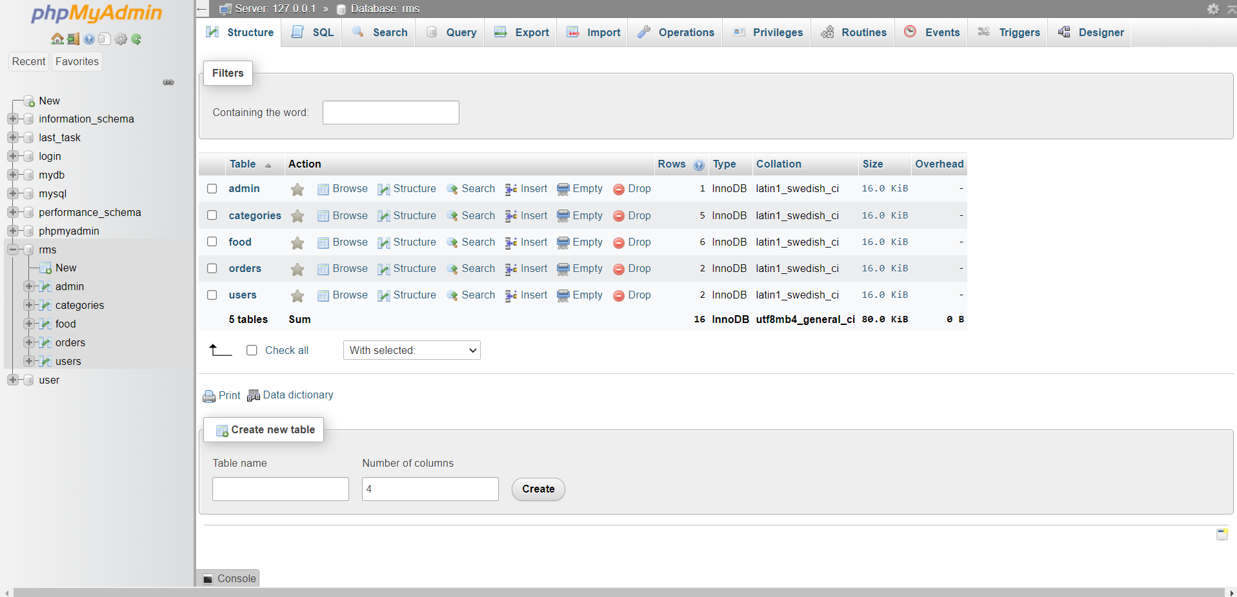

* **Detailed Photos of all the tables:**
* **Admin Table:**

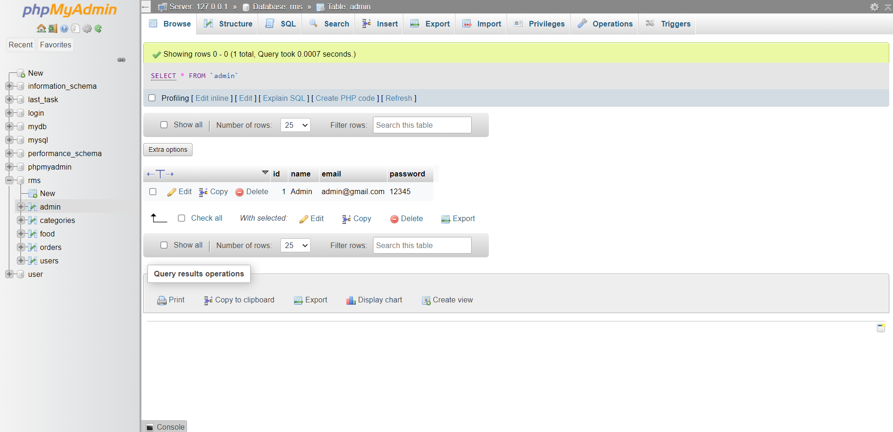

* **Categories table:**

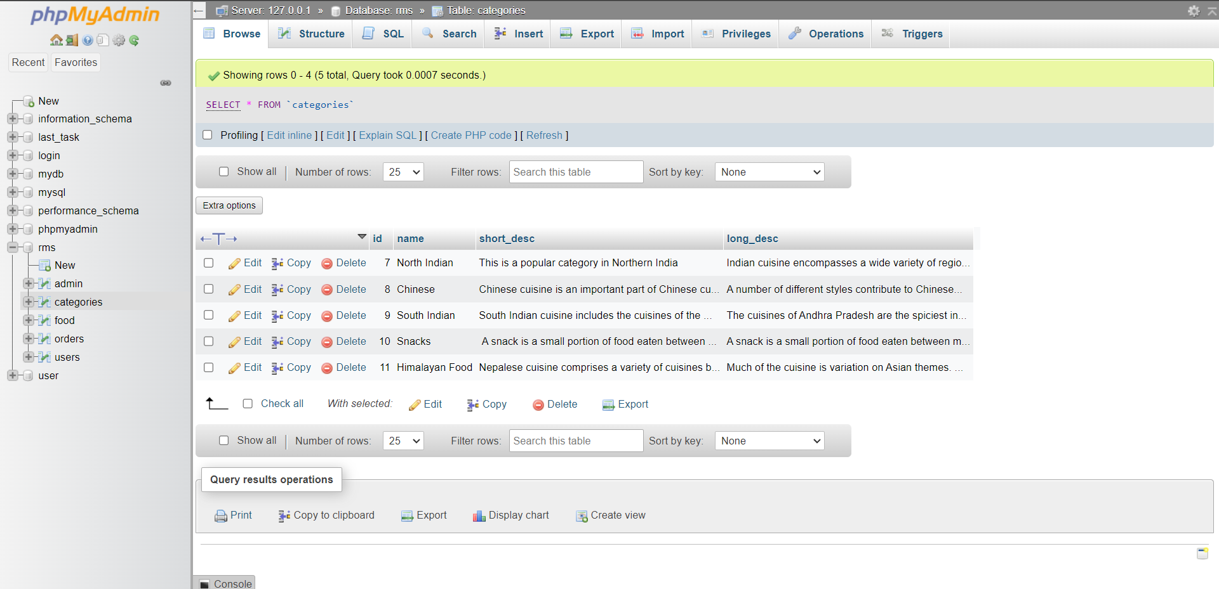

* **Food Items Table:**

* **Order list table:**

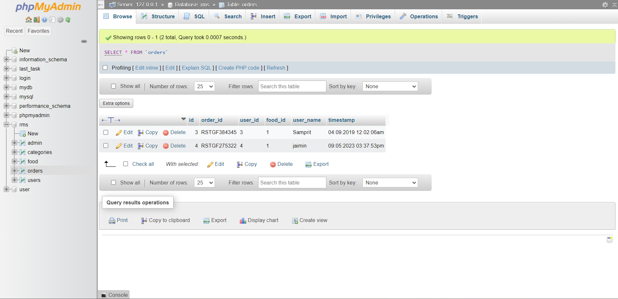

* **User list table:**

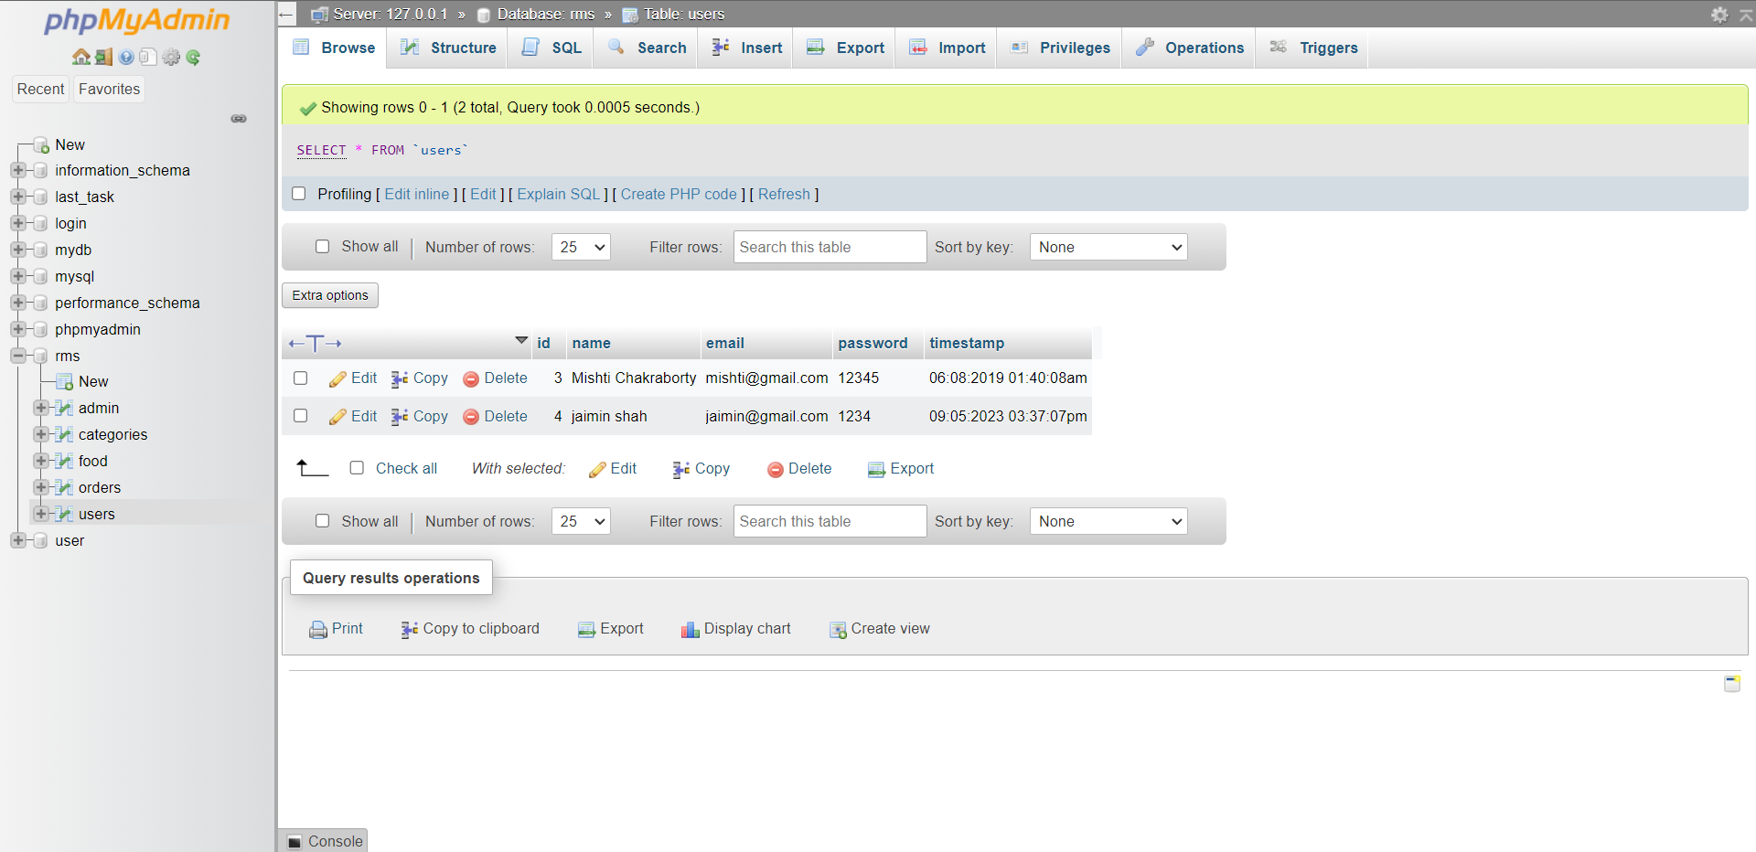

**Admin front-end:**

* **Admin login page:**

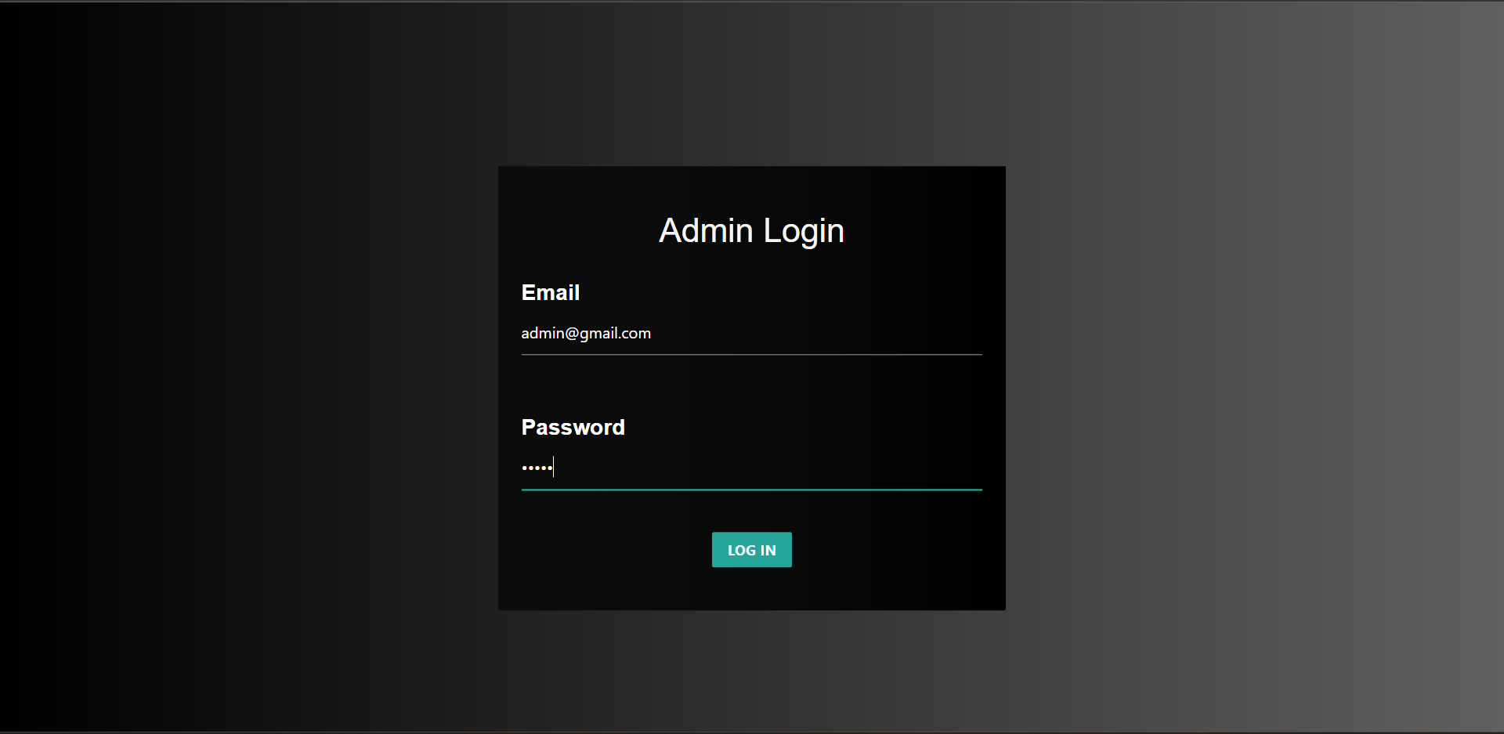

* **Admin dashboard:**

* **Admin food items record page:**

* **Admin Categories Page:**

* **Admin order list page:**

